Mike Piehl’s Blockchain

Supply Chain Project

This DApp is designed to track a piece of equipment throughout its entire life. The process will begin with the original manufacture of the equipment, and follow the equipment through the entire supply chain, including any aftermarket repairs or upgrades that occurred to the equipment. Finally, when the equipment is no longer usable, it will be decommissioned and the DApp will end the tracking process.

The idea is that once a piece of equipment is manufactured, it may make change hands multiple times before an end-user ever starts using the product. If the equipment is large enough or expensive enough, it will also be repaired or upgraded through it’s lifecycle.

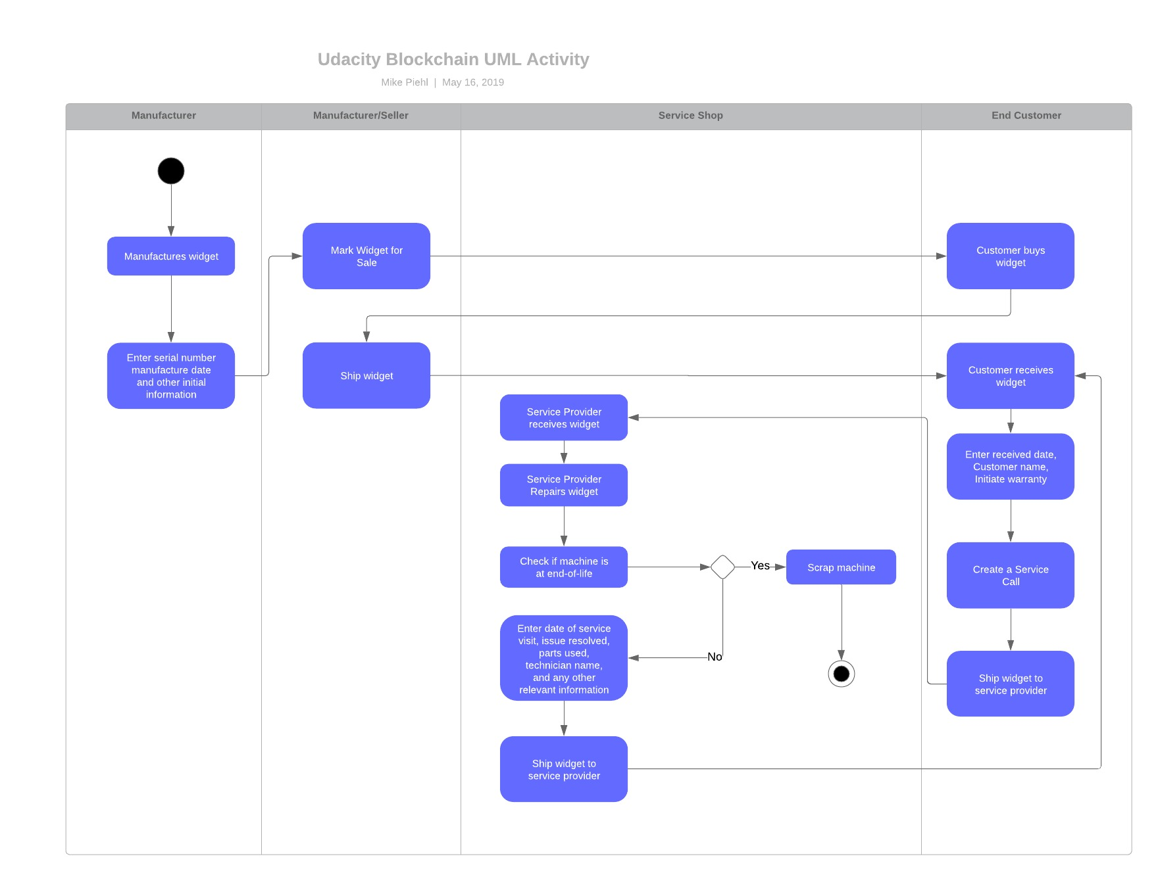

As the Activity diagram shows, we will include the original manufacturer, who may or may not be the seller. For our purposes, we will assume the equipment is produced and sold by the same actor. The code is setup to be generic, so that a seller can be a manufacturer, and also a consumer.

Finally, once the product is in use, we will track when the end customer needs service. This will be done manually by the end-user in the case of a breakdown. The seller will then perform a repair at the seller’s repair facility. The equipment will be repaired, and the technician will log the details in a document that will be stored on the IPFS. The block will contain the address to the IPFS document. If the item can no longer be restored to working condition, the EOL flag will be set.

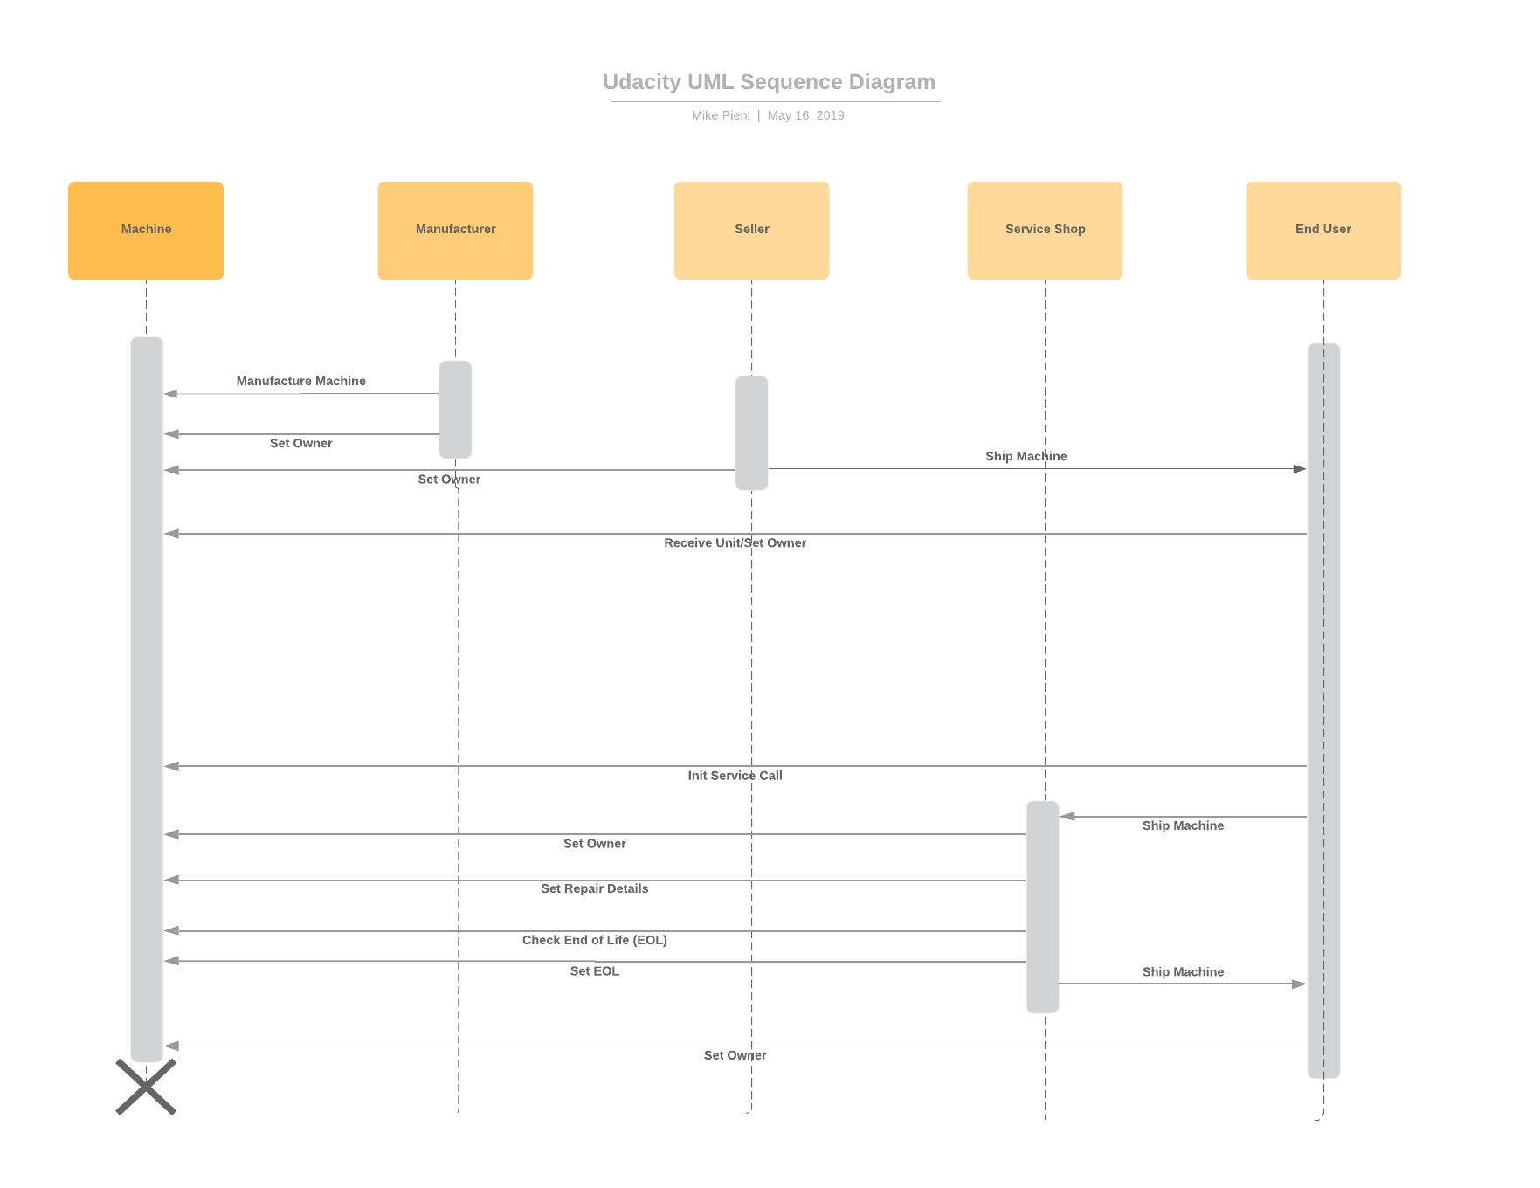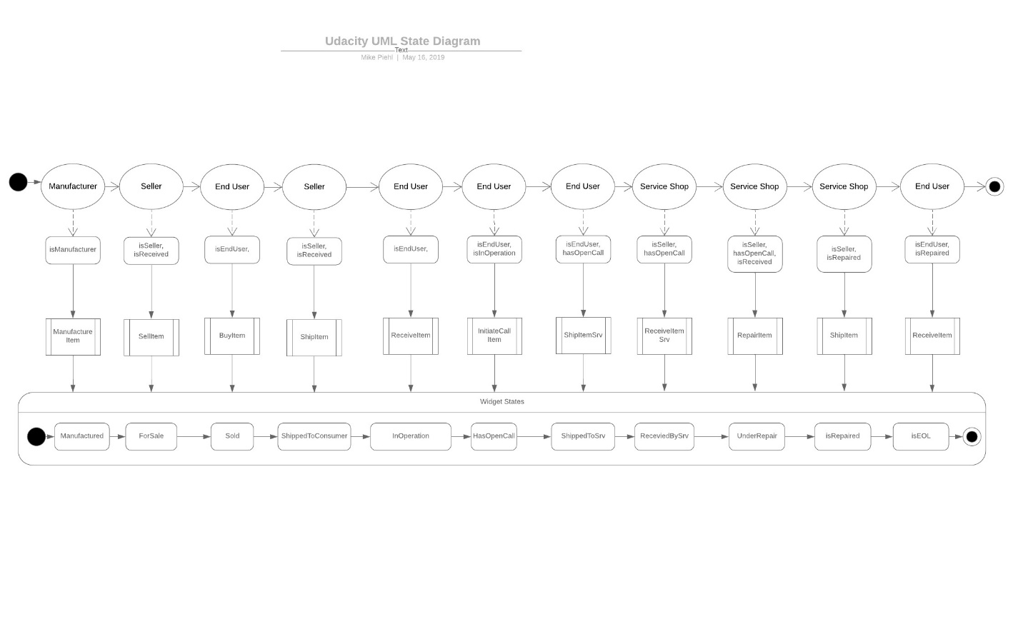

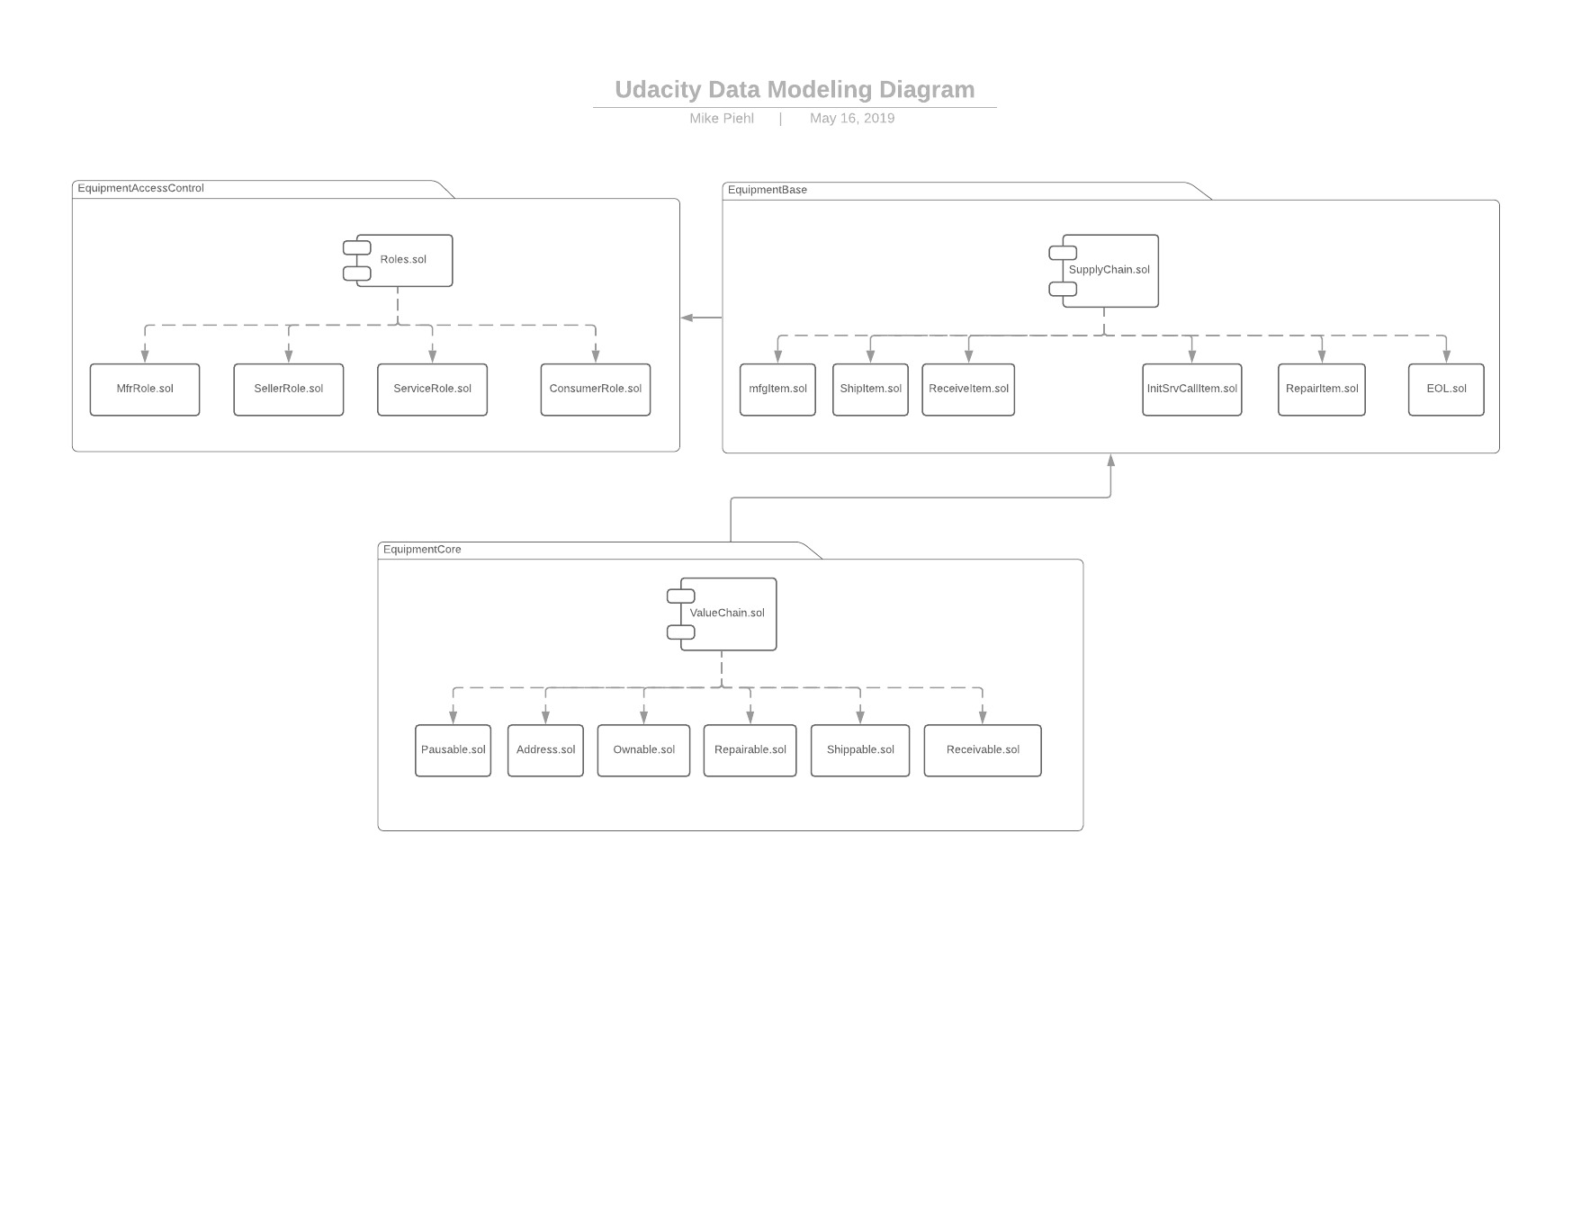

The DApp will leverage the Truffle Box: Webpack to expedite the process.

The primary libraries that will be leveraged include:

* Web3 – used to link the DApp to the web.
* Openzepplin – simplify the payment process
* truffle-hdwallet-provider – to simplify linking wallets between Infura & Metamask

Future functionality can include:

* Field service visits (no change of owner during the process)
* Warranty Checking
* Extended Warranty Checking
* Billing the customer (in Ethereum) for non-warranty repairs
* Having a separate Repairer Role. Currently the Seller is always the Repairer.